Lab 5: Examining the Registry
What You Need for this lab
  - Install Virtualbox : https://www.virtualbox.org/wiki/Downloads
  - Install Kali 2021.4. : https://old.kali.org/kali-images/kali-2021.4/
    - Notes: Suggest You configure the disk size of Kali VM 80G because the size of each leakage cases image is 30G+
    - Add new virtual hardisk size 20 GB
  - Tools RegRipper 3.0
  - Download DD images
- https://www.dropbox.com/s/u4axlx8eomgwfdc/cfreds_2015_data_leakage_pc.7z.001
- https://www.dropbox.com/s/pyq50s2cri6yftf/cfreds_2015_data_leakage_pc.7z.002
- https://www.dropbox.com/s/cxvzuiupmqc7l99/cfreds_2015_data_leakage_pc.7z.003
Step 1.
Unzipped the DD image
Verify the unzipped DD image
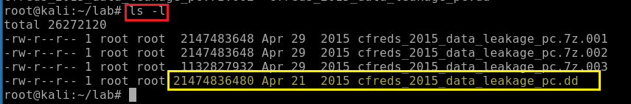
Verify the unzipped DD image with MD5
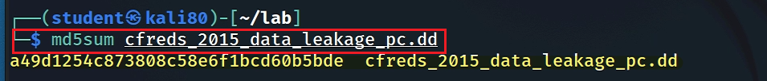
Step 2.
Exam partitions of the DD image using fdisk
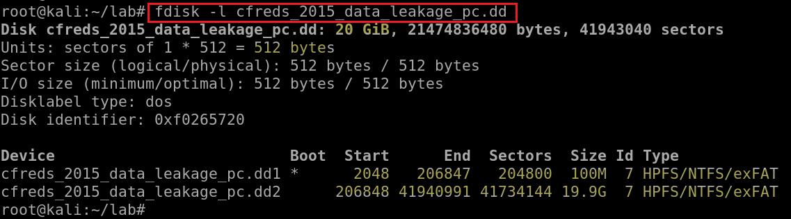
List file/directory names of the system volume
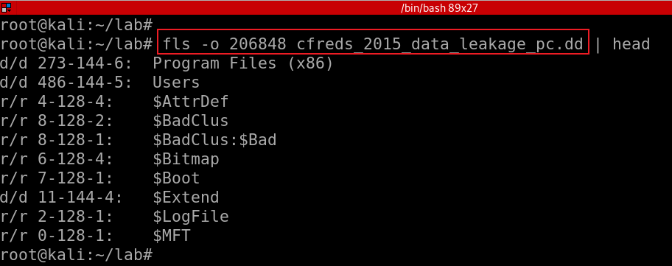
If your VM doesn’t support auto-mounting
Create a folder as the mount point
Mount partition 2 to the mounting point
Copy HKEY_LOCAL_MACHINE (Hive) files to \lab
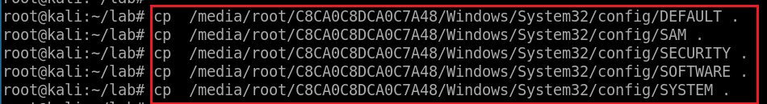
Verify five files
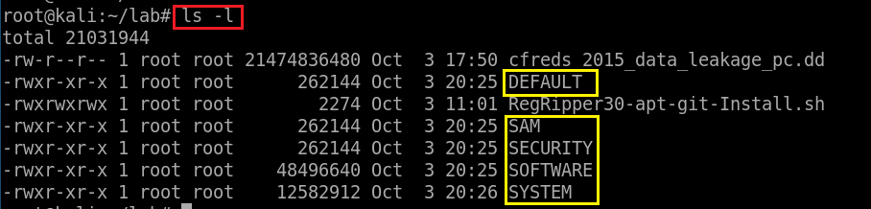
Step 3.
Verify you have the dd image
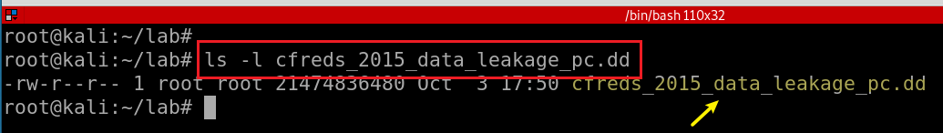
Compute MD5 and SHA1 of the DD image
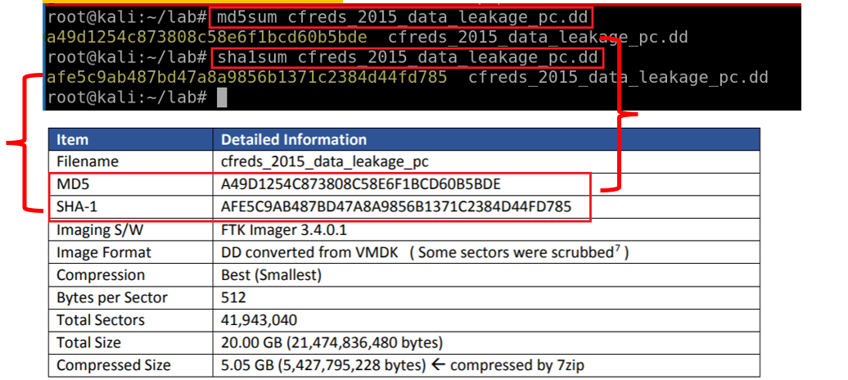
Show partitions of the image
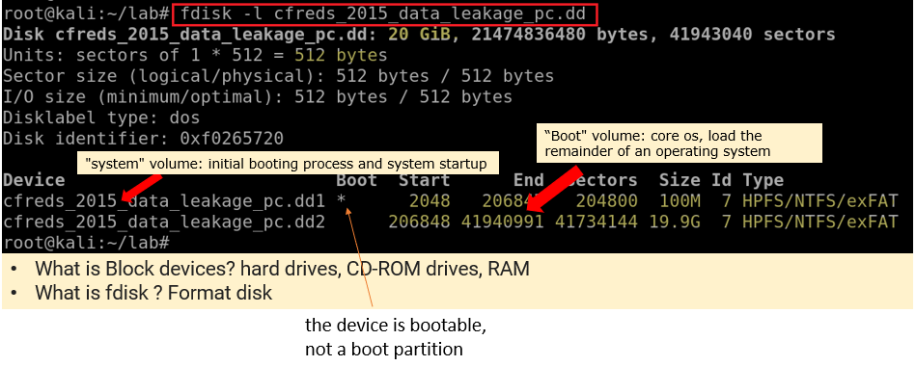
Show partitions and unallocated space using mmls
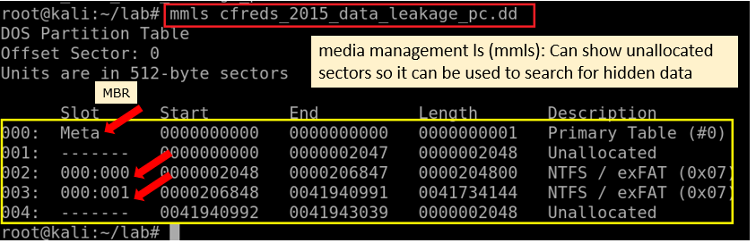
Display file system statistics and metadata information from a disk image (first partition)
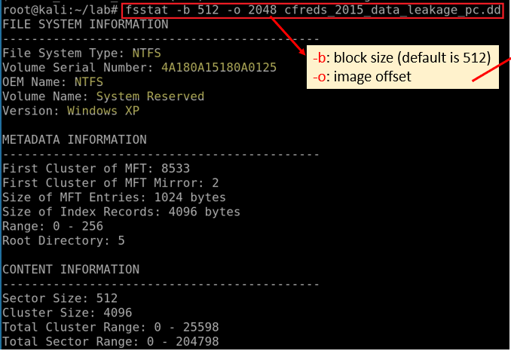
List the second partition details
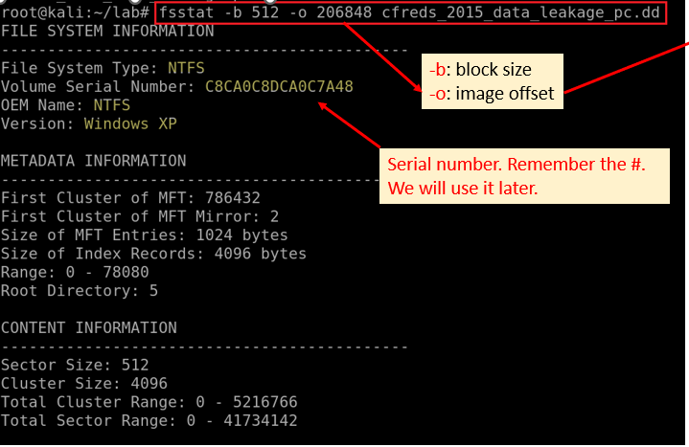
List all deleted .docx files in the whole partition?
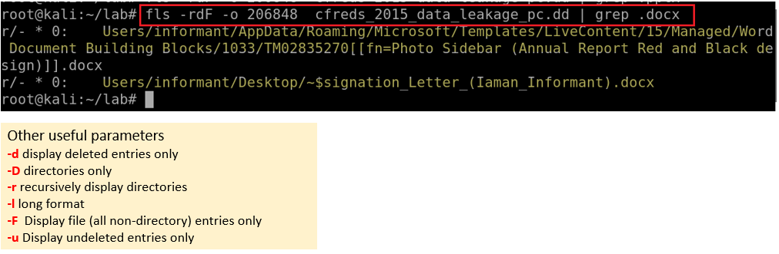
Verify system information

Verify Users’ information
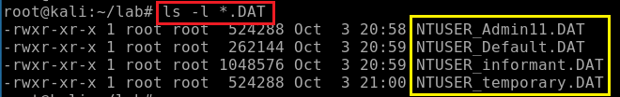
What is the installed OS information in detail?
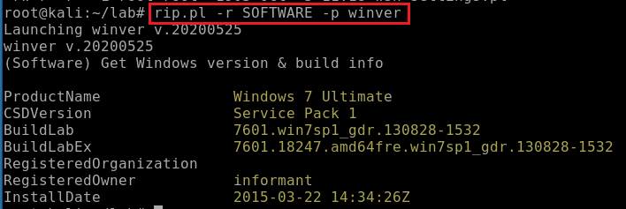
What is the computer name?
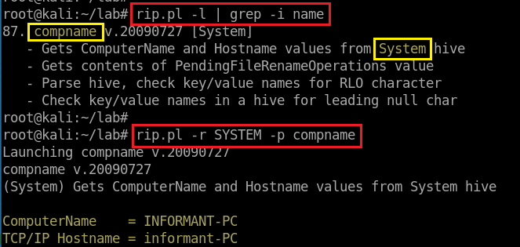
How many accounts does the system have?
Search for profiles
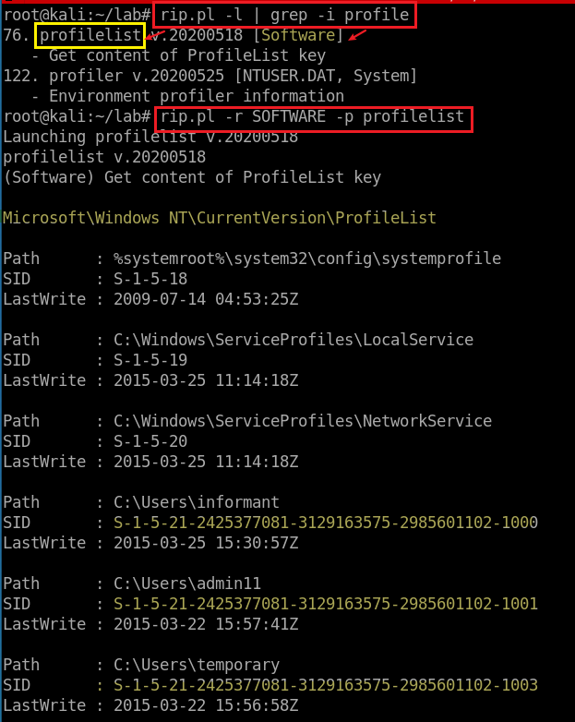

Find and search for Security Accounts Manager (SAM) information
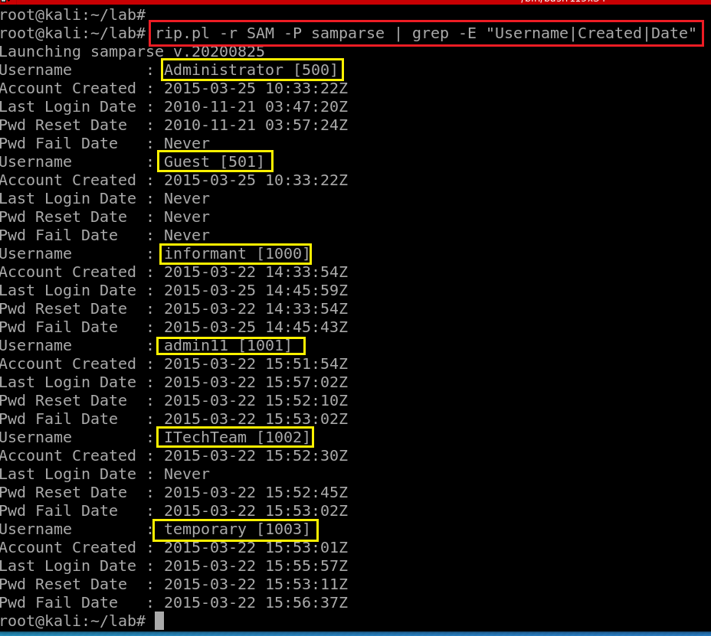
How many accounts does the system have?

When is the login time?

Who was the last user to logon into PC?

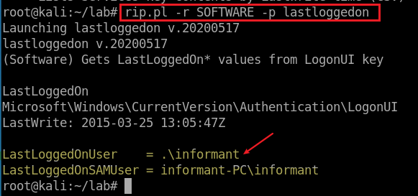

When was the last recorded shutdown date/time?

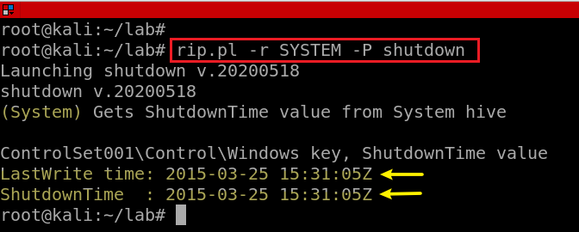
Explain the information of network interface(s) with an IP address assigned by DHCP.

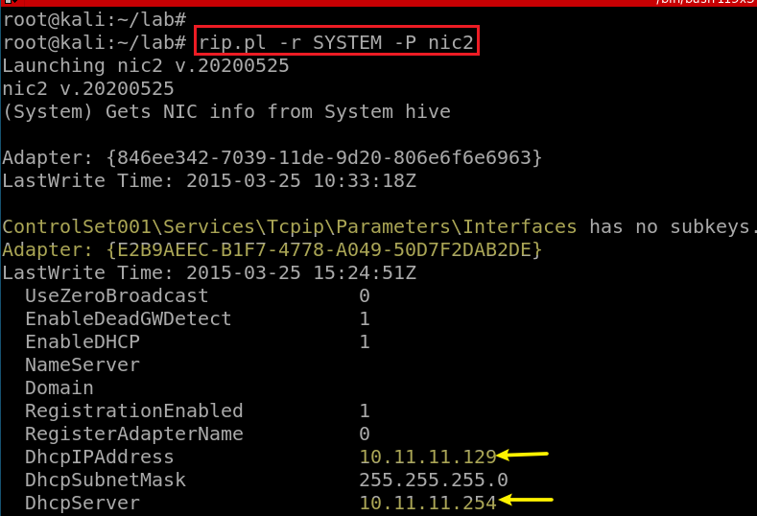

YOU MUST SUBMIT A FULL-SCREEN IMAGE FOR FULL CREDIT!
Save the document with the filename "YOUR NAME Lab 5.pdf", replacing "YOUR NAME" with your real name.
Email the image to the instructor as an attachment to an e-mail message. Send it to: xxx@fe.edu.vn with a subject line of "Lab 5 From YOUR NAME", replacing "YOUR NAME" with your real name.

